Starforge Printing is a platform where anyone can go to get quality 3D prints just by uploading an STL. You choose what material you want your model printed in and a quote will be sent back with a list of different quantities and the prices for each. The project is self-acquired since our Etsy shop has seen great success selling 3D printed items and custom prints are in high demand.

Research
- Treatstock- Middle man platform that offers 3d printing, cnc, and cutting services. There are reports that this company takes a long time to send payouts to customers if at all.

- Craftcloud- A broker platform that connects users with companies who provide 3d printing cnc machining, metal fabrication, and casting/molding services. Prices vary depending on want company you ultimately chose for your project.

- Shapeways- Offers CNC machining, 3D printing, and wax casting. Generally, a popular and trusted service that has only improved since it was taken over by new management last year.

Use Cases
- Create Account
- Login to account
- Delete account
- Upload STL
- Request Quote
- Make payment
- Order Tracking
- Cancel Order
- Adjust model infill strength
- Adjust model outer wall layers
- Order status
- Report order issue
- Adjust order quantity
- Edit product name
- Adjust model scale
- Generate Sales report
- Manage Customer Order
- Send Quote
- View Print success report
- Update order status

WBS
- Frontend
1.1 Account Management
- Create Account
- Login To Account
- Delete Account
- Password Reset
1.2 3D Model Management
- Upload STL
- Adjust Model Size
- Adjust Model Strength
1.3 Order Management
- Make Payment
- Track Order
- Request Cancellation
1.4 Customer Dashboard
- Uploaded Models
- Order History
- Account Settings
- Backend
2.1 Payment Processing
- PayPal Integration
- Tax Collection
- Shipping Calculation
2.2 Authentication
- Login Storage
- 2FA
- Login History Log
2.3 3D Model Processing
- File Storage
- 3D Model Auto Slicing
- Price Calculation
  - Quote/Pricing
- Price of material
- Price for Quantity
- Auto Quote Estimation

Gantt Chart
ID | Name | Week 1 | Week 2 | Week 3 | Week 4 | Week 5 | Week 6 | Week 7
1.1 | Account Management
1.2 | 3D Model Management
1.3 | Order Management
2.1 | Payment Processing
2.2 | Authentication
2.3 | 3D Model Processing

Backlog
-Login
- Account Registration Priority=High
- Account Login Priority=High
- Change Password Priority= Medium
- Account Logout Priority= Medium
- Account Deletion Priority= Medium
-Ui for operator and user
- Homepage Priority=High
- About Us Priority=High
- Account Setting Priority= Medium
- Upload STL Page Priority= Medium
- Adjust Model Size Priority= Medium
- Adjust Model Color Priority= Medium
- Adjust Model Strength Priority= Medium
- Get Model Quote Priority=High
- Cart Priority=High
- Payment Screen Priority=High
- Order Tracking Screen Priority= Medium
- Contact Us page Priority= Medium
- Uploaded Models Page Priority= Medium
- Quantity Selection Widget Priority=High
- Quote Approval Screen Priority= Medium

-Backend processes for operator and user
- Account Storage Priority=High
- 3D Model Storage Priority=High
- Quote Storage Priority=High
- Quote Calculation Service Priority=High
- Messaging Service Priority= Medium
- 3D Model Slicer Priority=High
- Shipping Calculation Priority=High
- Price Calculation Priority=High
- 2FA Priority= Medium
- Order Payment Processing Priority=High
- Order Tracking Updater Priority= Medium
- Refund System Priority= Medium
- Refund Processing Priority= Medium
- Email Notification Service Priority= Priority= Medium
- Review System Priority= Priority= Medium
- Inventory Updater Priority=High
-Reporting for operator and user
- Order History Log Priority= Priority= Medium
- Login History Log Priority= Priority= Medium
- Earnings Report Priority=High
- Uploaded Models Report Priority=High
- Messaging Report Priority= Low
- Delivery Report Priority= Low
- Review Report Priority= Low
- Traffic Report Priority= Low
- Print Success/Failure Report Priority= Low
- Print Completion Time Report Priority= Low

Risk Factors
- Technical
- File compatibility- Customers may upload outdated or corrupted STL files
- File Security- Customer STL files could be compromised in a security breach
- Slicing Failure- The slicing programs may not use the right settings when converting the model to a printable object
- Quote Failure- The quoting system may not give an accurate estimate for the
- Schedule
- Print Delay- Do to failures or a surplus of order, prints may not make it out on time before the due date.
- Testing Delay- Printers might fail during the testing phase
- Implementation Delay- Implementation of the payment or quoting systems may take longer than expected
- Launch Date Change- Stockholders may request that the launch date be moved
- Financial
- Slicer Software Licenses- Software licenses may need to be purchased for slicer integration
- Security Costs- Security costs could increase as development progresses
- Storage Costs- File storage needs will increase with more customers
- Shipping Costs- Shipping costs may fluctuate greatly between different locations and seasons
- People
- Developer Absence- Developer could be absent or quit during a critical time
- Unskilled Developer- Developer may not be as skilled as advertised
- Developer Communication- Developers may not communicate effectively causing the same work to be done by multiple different
- Requirements- Stakeholders may take long to specify requirements, especially for new developments

Risk Register
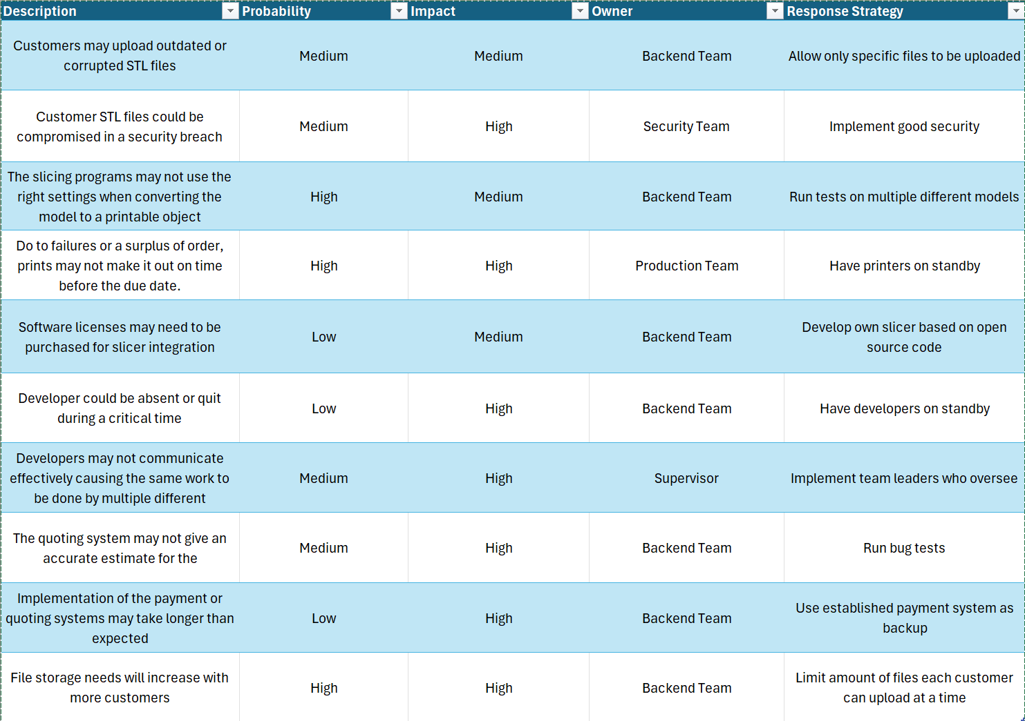

Communication Plan
Backend Team- Meetings held twice a week on teams
Production Team- Meetings held weekly in person
Security Team- Meetings held bi-weekly on teams unless there’s an emergency
Supervisors- Meetings held weekly on teams

Roles & Resources
James Lee – Developer – Low Skill - 100%
Morgan Black – Project Manager – High Skill – 100%
Johnny Silverhand – Quality Assurance – Medium Skill – 100%
Dave Patel – User Experience – Low Skill – 100%
Dexter Morgan – DevOps – High Skill – 75%
Walter White – Business Analyst – High Skill – 50%
Jesse Pinkman – Product Owner – Medium Skill – 100%
Rick Grimes – Subject Matter Expert – High Skill – 25%

- Team assumptions and per-role annual cost (hours * rate):​
- - PM: (672 hours * $80/hr) = $53760
- - Developer: (672 hours * $50/hr) = $33600
- - QA: (672 * $60/hr) = $40320
- - UX: (672 * $50) = $33600
- - DevOps: (504 * $75) = $37800
- - BA: (286 * $75) = $20100
- - PO: (672 * $75) = $50400
- - SME: (168 * $70) = $11760
- Labor subtotal = 53760 + 33600 + 40320 + 33600 + 37800 + 20100 + 50400 + 11760 = 281,340
- Infrastructure & other costs = Cloud 1,000/month * 12 = 12,000; Licenses 4,000; APIs 2,400; Security 5,000; Hardware 20,000; Training 5,000 ->subtotal = 48,400
- Overhead/Benefits (25% of labor) = 0.25 * 281,340 = 70,335
- Grand total = 281,340 + 36,412 + 70,335 = 388,087

Task / Role | Dev | PM | QA | UX | DevOps | BA | PO | SME
Requirements | I | A | R | I | C | I | C | I
3D Model Management | C | I | A | R | C | C | I | I
Order Management | I | R | I | I | C | I | C | I
Payment Processing | A | I | C | C | C | I | C | I
Authentication | R | I | C | I | C | C | I | A
3D Model Processing | I | C | I | I | R | A | I | I
UX | C | I | C | A | I | C | C | I
Account Management | I | I | I | C | A | R | I | I
Testing | I | C | C | I | C | I | A | I
Release | C | I | C | I | I | I | R | I

